Connect Skill Evaluation Sheet
Candidate Name: | Dasari Rana Prathap |  | 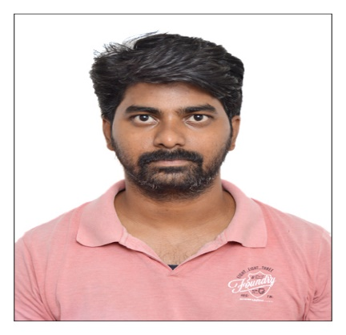
Total Experience: | 5.4 years
Relevant Experience: | 4.0 years
Notice Period: | Immediate
MSP Input |  | Supplier Input
Candidate Skills | Mandatory/ Optional | Name of Projects in which  the skills were used  (Add rows if necessary) | No: of years worked  in each Project | Description of work done  using the skill
Primary Skill 1: | Automation testing selenium | Signet (jewellery project)  Indus insurance project |  | Automation testing selenium, Automation testing API
Primary Skill 2: | Automation testing API | Signet (jewellery project)  Indus insurance project |  | Automation testing selenium
Primary Skill 3: | Manual testing | Signet (jewellery project)  Indus insurance project |  | Automation testing selenium
Secondary Skill 1: | O
Secondary Skill 2: | O
Secondary Skill 3: | O

Dasari Rana Prathap

_________________________________________________________________________________________________________________________

dasariranaprathap2@gmail.com Contact Info: +917416005483
---------------------------------------------------------------------------------------------------------------------------------------

PROFESSIONAL SUMMARY
- Having 5+ Years of experience in Manual and Automation on Web based applications.
- Well versed with Handling Elements in Selenium Web driver.
- Worked on Requirement analysis, Test case preparation, Test Execution and Test results validation.
- Experience in Automation using Selenium Web Driver.
- Involved in Functional and Regression testing.
- Having hands on experience in all phases of Software Test Life Cycle (STLC)and Bug Life Cycle.
- Good Experience in Working on Data Driven Framework with Apache POI.
- Hands of experience on Framework like BDD Cucumber, TestNg, Data Driven and Page Object Model Frameworks.
- Experience on Agile Methodology.
- Experience on Jenkins (CI/CD).
- Experience in using GitHub for project code maintenance.
- Experience in Core JAVA.
- Experience on API automation using Rest Assured.
- Experience on Postman

EXPERIENCE SUMMARY:

- Worked for Bridgeline Digital Pvt Ltd, Bangalore as Software Test Engineer from July 2018 to October 2023

EDUCATIONAL QUAIFICATIONS

- B. Tech in Bheema Institute of technology and science from JNTUA in Adoni, Kurnool district, Andhra Pradesh

TECHNICAL SKILS

Operating System : Windows
Development Tools : Eclipse
Automation Tools : Selenium Web Driver, Testng, Postman, Rest Assured
Frameworks : BDD Cucumber, Testng, Page Object Model, Data driven
Language : Core Java
Database : Oracle 10g, SQL
Defect Reporting Tool : Jira
Build Tool : Maven

Professional Experience:

Project #2:
Title : Experience Memo
Domain : E-Commerce
Technologies : PHP, MYSQL, JQUERY, AJAX, Java Script, Bootstrap.
Testing Approach : Manual Testing& Automation Testing (Selenium, Rest Assured)

Description :
Memo is an E-Commerce site for shopping of jewelry. Special Designs of jewelry by talented designers.
Responsibilities:
- Understanding of Requirements and functional Specification of the Application.
- Involved in analyzing and prepared test scenarios and test cases to cover over all quality assurance testing.
- Executed test scripts using selenium and evaluated test cases for test automation.
- Preparing the Automation scripts using BDD Cucumber Framework and Executing Automation scripts.
- Perform Automation testing and created various test results to track the testing results.
- Uploaded the Scripts into Git repository, provided the test result and reports using Testng based on my framework.
- Performed Defect Tracking in JIRA.
- Performed API manual testing using Postman and Swagger
- Automated the API test cases using Rest Assured using Java

Project #1:
Title : Indus Insurance
Domain : Insurance
Environment : Windows
Testing Approach : Manual Testing & Automation Testing

Description:
Indus Insurance is designed for Providing Different Insurance Coverage with Different Plans and Insured term values. It Suits to all the Middle Level and High-Level Individuals across the Country. A Life insurance policy is a contract between an individual (termed as insured) and an insurance company (insurer) to pay the insured, or his nominated heirs, a specified sum of money on the happening of an event or on maturity. Which has four modules named as Administrator, Branch Manager, Agent and Customer.

Responsibilities:

- Understanding Requirement Specifications.
- Actively participating in understanding and identifying the test scenarios & test cases.
- Prepared Test Cases as per the System Requirement Specifications.
- Performed Test Case Execution and Defect Reporting using Jira.
- Involved in Functional, and Regression testing.
- Executed test scripts using selenium and evaluated test cases for test automation.
- Preparing the Automation scripts and Executing Automation scripts.
- Perform Automation testing and created various test results to track the testing results
- Environment: Java, JSP, HTML, Oracle, Jira and Windows XP.
- Performed API manual testing using Postman and Swagger
- Automated the API test cases using Rest Assured

PERSONAL DETAILS-

Full Name : D. Ranaprathap
Date of Birth :22-08-1994
Gender : Male
Languages known : Telugu, Hindi & English
Nationality : Indian.

DECLARATION:

I hereby furnish that the information furnished above is true to the best of my knowledge and I bear the responsibility for the correctness of given details.

Date:
Place: (D.RanaPrathap)

